Practial - 10
JavaScript and JQuery

- Create an AJAX application to read the name of the person from the drop down list and display firstname, lastname, age, date of birth and contact number from the database and display in tabular format within the same page.
Use JQuery hide and show effects to make the table data appear and disappear to and from the screen.

- Write a jQuery program to demonstrate hide, hover effects using jQuery classes and implement mouse and key events with suitable form controls.

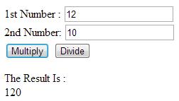
- Write a JavaScript program to calculate multiplication and division of two numbers (input from user). Implement Error Handling in the program.
Sample form :

4. Write a JavaScript program to find the types of a given angle. Implement Error Handling in the program.

Types of angles:
    - Acute angle: An angle between 0 and 90 degrees.
    - Right angle: An 90 degree angle.
    - Obtuse angle: An angle between 90 and 180 degrees.
    - Straight angle: A 180 degree angle.

    - Write a JavaScript program to replace all the numbers with a specified number of a given array of integers.

